Assignment No 6
Q1. What are functions of network coding? State various applications of network coding
Network coding is young ϖ Coding at a node in a packet network (where data are divided into packets and network coding is applied to the contents of packets) / More generally, coding above the physical layer ϖ Refer to coding at a node in a network as network coding ϖ Coding at a node in a network with error-free links. This distinguishes the function of network coding from that of channel coding for noisy links Que : - What is Network Coding Good For ? Ans : Network coding can improve 1. Throughput 2. Robustness 3. Complexity 4. Security

Throughput ¬ The most well-known utility of network coding is increase of throughput ¬ This throughput benefit is achieved by using packet transmissions more efficiently, i.e., by communicating more information with fewer packet transmissions. Fig.1. shows the butterfly network. In this network, every arc represents a directed link that is capable of carrying a single packet reliably. There are two packets, b1 and b2, present at the source node S, and aim is to communicate the contents of these two packets to both of the sink nodes, t1 and t2. The packet that is output is b1 ⊕ b2, formed from the bitwise XOR of b1 and b2. Conclusion : The nine packet transmissions that are used in the butterfly network communicate the contents of two packets
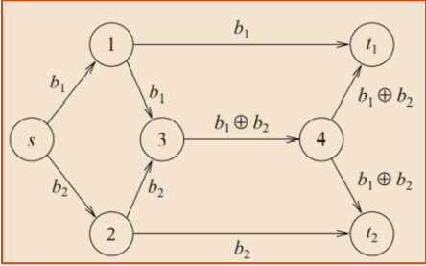
A simple modification of the butterfly network leads to an example that involves two unicast connections that, with coding, can be established and, without coding, cannot Fig 2. shows the modified butterfly network. In this network, every arc represents a directed link that is capable of carrying a single packet reliably. There is one packet b1 present at source node s1 that we wish to communicate to sink node t1 and one packet b2 present at source node s2 that we wish to communicate to sink node t2
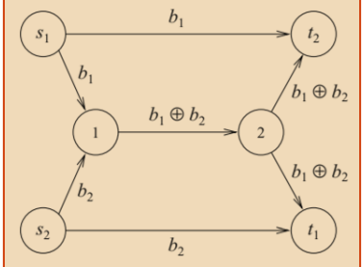
Network coding can also be extended to wireless networks and, in wireless networks, it becomes even easier to find examples where network coding yields a throughput advantage over routing
Fig. 3 shows the wireless butterfly network. In this network, every hyperarc represents a directed link that is capable of carrying a single packet reliably to one or more nodes. There are two packets, b1 and b2, present at the source node s, and aim is to communicate the contents of these two packets to both of the sink nodes, t1 and t2.
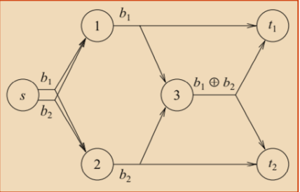

Robustness 1. Robustness to packet losses Packet loss arises for various reasons in networks, which include buffer overflow, link outage, and collision. Ways to deal with such losses:- 1. To set up a system of acknowledgments by TCP mechanism 2. Use channel coding/ erasure coding. that introduces a degree of redundancy to the packets so that the message can be recovered 3. Network coding scheme that applies additional coding at intermediate code without decoding 2. Robustness to link failures 1. Besides robustness against random packet losses, network coding is also useful for protection from non-ergodic link failures. 2. Live path protection, where a primary and a backup flow are transmitted for each connection, allows very fast recovery from link failures, since rerouting is not required. 3. However, this approach doubles the amount of network traffic.

By allowing sharing of network resources among different flows, network coding improves resource usage.
Complexity ¬ In some cases, although optimal routing may be able to achieve similar performance to that of network coding, the optimal routing solution is difficult to obtain ¬ For instance, Steiner trees selection is considered for multicast routing, which is complex even in a centralized setting, while the corresponding problem with network coding is a linear optimization that admits low complexity distributed solutions. ¬ Network coding has also been shown to substantially improve performance in settings where practical limitations necessitate sub-optimal solutions
Security ¬ From a security standpoint, network coding can offer both benefits ¬ The butterfly network . Suppose an adversary manages to obtain only the packet b1 ⊕ b2. ¬ With the packet b1 ⊕ b2 alone, the adversary cannot obtain either b1 or b2; thus we have a possible mechanism for secure communication. ¬ In this instance, network coding offers a security benefit

Q2.Explain the procedure of encoding in hamming codes

Hamming Code
Hamming code is a block code that is capable of detecting up to two simultaneous bit errors and correcting single-bit errors. It was developed by R.W. Hamming for error correction.
In this coding method, the source encodes the message by inserting redundant bits within the message. These redundant bits are extra bits that are generated and inserted at specific positions in the message itself to enable error detection and correction. When the destination receives this message, it performs recalculations to detect errors and find the bit position that has error.

Encoding a message by Hamming Code
The procedure used by the sender to encode the message encompasses the following steps −
- Step 1 − Calculation of the number of redundant bits.
- Step 2 − Positioning the redundant bits.
- Step 3 − Calculating the values of each redundant bit.
Once the redundant bits are embedded within the message, this is sent to the user.

Step 1 − Calculation of the number of redundant bits.
If the message contains m𝑚number of data bits, r𝑟number of redundant bits are added to it so that m𝑟 is able to indicate at least (m + r+ 1) different states. Here, (m + r) indicates location of an error in each of (𝑚 + 𝑟) bit positions and one additional state indicates no error. Since, r𝑟 bits can indicate 2^{r}𝑟 states, 2^{r}𝑟 must be at least equal to (m + r + 1). Thus the following equation should hold 2^{r} ≥ m+r+1

Step 2 − Positioning the redundant bits.
The r redundant bits placed at bit positions of powers of 2, i.e. 1, 2, 4, 8, 16 etc. They are referred in
the rest of this text as r₁ (at position 1), r₂ (at position 2), r₃ (at position 4), r₄ (at position 8) and so on.

Step 3 − Calculating the values of each redundant bit.
The redundant bits are parity bits. A parity bit is an extra bit that makes the number of 1s either even or odd. The two types of parity are −
- Even Parity − Here the total number of bits in the message is made even.
- Odd Parity − Here the total number of bits in the message is made odd.
Each redundant bit, r_{i}, is calculated as the parity, generally even parity, based upon its bit position. It covers all bit positions whose binary representation includes a 1 in the i^{th} position except the position of r_{i}. Thus −
- r₁ is the parity bit for all data bits in positions whose binary representation includes a 1 in the least significant position excluding 1 (3, 5, 7, 9, 11 and so on)
- r₂ is the parity bit for all data bits in positions whose binary representation includes a 1 in the position 2 from right except 2 (3, 6, 7, 10, 11 and so on)
- r₃ is the parity bit for all data bits in positions whose binary representation includes a 1 in the position 3 from right except 4 (5-7, 12-15, 20-23 and so on)

Decoding a message in Hamming Code
Once the receiver gets an incoming message, it performs recalculations to detect errors and correct them. The steps for recalculation are −
- Step 1 − Calculation of the number of redundant bits.
- Step 2 − Positioning the redundant bits.
- Step 3 − Parity checking.
- Step 4 − Error detection and correction

Step 1 − Calculation of the number of redundant bits
Using the same formula as in encoding, the number of redundant bits are ascertained.
2^{r} ≥ m + r + 1 where m is the number of data bits and r is the number of redundant bits.

Step 2 − Positioning the redundant bits
The r redundant bits placed at bit positions of powers of 2, i.e. 1, 2, 4, 8, 16 etc.

Step 3 − Parity checking
Parity bits are calculated based upon the data bits and the redundant bits using the same rule as during generation of c₁,c₂ ,c₃ ,c₄ etc. Thus
c₁ = parity(1, 3, 5, 7, 9, 11 and so on)
c₂ = parity(2, 3, 6, 7, 10, 11 and so on)
c₃ = parity(4-7, 12-15, 20-23 and so on)

Step 4 − Error detection and correction
The decimal equivalent of the parity bits binary values is calculated. If it is 0, there is no error. Otherwise, the decimal value gives the bit position which has error. For example, if c₁c₂c₃c₄ = 1001, it implies that the data bit at position 9, decimal equivalent of 1001, has error. The bit is flipped to get the correct message.

Q3 State types of Interference and how to supress them

Interference types in cellular networks
The following types of inference may be associated with wireless networks; Self interference, multiple access interference, CCI, and ACI.

2.1. Self-interference
Self-interference is due to interference induced among signals that are transmitted from a shared transmitter. The amount of interference induced depends on the modulation type. In OFDM, self-interference among sub carriers due to carrier frequency offsets caused by oscillator mismatches, Doppler Effect and fast fading caused by motion of the transceivers. Transceiver non-idealities such as amplifier non-linearity and IQ imbalance may also be source self-interference. Interference between the uplink and downlink transmissions in a FD duplex system may be also classiﬁed as self-interference, as it occurs among signals send on the same two-way connection. This interference is mitigated by employing duplex ﬁlters. The impact of self-interference may be reduced by selecting the physical layer numerology such that the operating conditions and implementation technology are taken into account.

2.2. Multiple access interference
Multiple access interference refers to the interference induced among the transmission from multiple radios using the same frequency resource to a single receiver. In theory, the physical layer will allow orthogonal multiple accesses, however, factors such as synchronization errors, RF circuitry non-idealities, and the effect of wireless propagation channel will not allow orthogonality to be maintained in practice. An essential method of maintaining orthogonality in multiple access scenarios is power control.

2.3. Co-channel interference
CCI between links that reuse the same frequency band (channel). It is also referred to as inter-cell interference in cellular systems. The effect of CCI may be minimized by employing fixed frequency re-use patterns. Common methods for CCI management in cellular networks include: Frequency re-use, MIMO techniques, Interference alignment, and adaptation to interference variation. High frequency re-use factor implies a constant data rate across the service area (reference). This situation leads to similar throughput experience by users at different locations of the cell, and the service rate distribution.
Another method of dealing with CCI is by considering co-operation among transmitters. Such techniques have been investigated in the literature under the name of network MIMO . In network MIMO, the interference channel is transformed to a broadcast channel by considering the co-operating transmitter as a single transmitter . Data traffic may be shared between multiple cooperating transmitters from which it may then be coherently transmitted to the destination receiver.

2.4. Adjacent channel interference
ACI is the interference induced between links that communicate in the same geographical location using neighboring frequency bands. A transmitter occupying a certain frequency band also leaks energy on frequency adjacent to that band. The out-of-band emissions are perceived as interference by other receivers. The effect of the out-of-band emissions may be quantified using the adjacent channel power ratio (ACPR).
Signals outside the nominal frequency band generate interference components on the in-band frequencies at the receiver. The adjacent channel sensitivity (ACS) determines the ability of the receiver to cope with an out-of-band interferer. The properties of the RF chain that contribute to ACS characteristics include; the quality of channel selection filters, analogue-to-digital converter bit width, and the linearity of amplifiers and mixers.

3. Interference reduction techniques

3.1. Intermodulation solutions
The amplitude modulation of signals containing two or more frequencies in a system with non-linearities is referred to as intermodulation. Intermodulation between constituent frequencies will result in additional signals at frequencies that are not just at harmonic frequencies of either, but also at the sum and difference frequencies of the original frequencies and at multiple of those sum and differences. The types of intermodulation of interest in co-located BS are; forward and reverse intermodulation (RIM). Forward intermodulation (FIM) components are induced in the victim receivers and are of major concern when they fall directly on the required signal. A knowledge-based filtering method was used to eliminate the FIM components. This method relies on the knowledge of co-located transceiver specifications and antenna configurations which makes it unsuitable for dynamic environments.

3.2. Frequency planning methods
Frequency (channel) allocation in cellular networks is an important subject amongst researchers, optimization engineers and mathematicians. The population of MU increases daily while available spectrum remains fixed. Hence, the frequency allocation problem is modeled as a multi-objective, multi-constraint optimization problem where given a number of BS and available channels it is required to find an optimal frequency plan that satisfy the channel demands of MU in a geographical area and the interference constraints. The common interference constraints in FAP problems are; co-channel, co-site and adjacent channel constraints. The solution methods applied to FAP are classified into two; Optimization techniques and heuristic search techniques.

3.3. Genetic algorithms
Evolutionary computation (EC) is a computational approach that models biological evolutionary principles to solve mathematical optimization problems. The field of evolutionary computation is sub-divided into; genetic algorithms, genetic programming, evolutionary strategies and evolutionary computation. EC draws mainly from the concept of biological genetics hence terminologies such as mutation, crossover, parent, chromosomes, genes, genome, selection etc. are used quantitatively to define processes involved in applying EC to optimization problems.

Q4.Explain use of Power control to suppress interference in cellular networks

Power control mechanisms have played an important role in the success of most digital cellular systems. Power control offers substantial benefits for the efficient and fair operation of the cellular system, supports QoS adaptations like rate control, and yet the basic power control algorithms involve feedback with as few as 1-bit and are simple to implement. These motivate most cellular systems to incorporate power control in the physical layer specification of the standard. In this concluding chapter of the monograph, we survey a selection of the implementations of the algorithms in previous chapters in operational networks, including those listed in Table 10.1. Power control implementations in cellular systems often consist of Open-loop power control (OLPC) and Closed-loop power control (CLPC). OLPC is a simple scheme that allows the transmitter to optimally select the transmit power by exploiting the similarity of the uplink and downlink channel in properties including distance-dependent attenuation and frequency-independent slow fading.

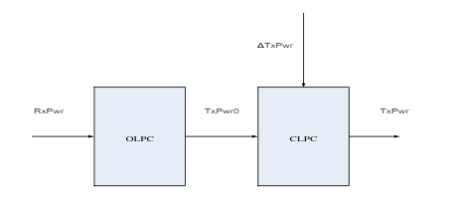

Q5Explain different Mac Protocol issues

Design issues of MAC Protocol :
Bandwidth Efficiency –
The shortage of data transfer capacity assets in these networks requires its proficient use. To evaluate this, we could state that bandwidth capacity is the proportion of the bandwidth used for data transmission to the complete accessible bandwidth capacity.
Quality of Service Support –
Quality of service support is difficult due to the mobility of the nodes. Once a node moves out of reach, the reservation in it is lost. In these networks, QoS is extremely important because if it is being used in military environments, the service support needed time to time.
Synchronization –
Some instruments must be found so as to give synchronization among the nodes. Synchronization is
significant for directing the bandwidth reservation.
Hidden Terminal Problem –
When there are two nodes, both are outside of each other’s range and try to communicate with same node within their range at the same time, then there must be packet collision.
Exposed Terminal Problem –
Uncovered nodes might be denied channel access pointlessly, which implies under usage of the bandwidth resources.

Q6. With reference to Scheduler Design, explain following components in brief : [6]
  - Classifier
  - Channel Quality
  - Scheduler

SCHEDULER DESIGN
❖ An efficient scheduling scheme must take into consideration some important parameters in the scheduling
decision such as a) Signal strength, b) Interference and c) Channel Quality
❖ Due to the rapidly and instantaneously changing nature of radio channel quality there must be a fast enough
scheduling algorithm to compensate for the changing in channel conditions.
❖ Fig. illustrates the scheduler design which consists of three main function modules. The scheduling scheme is
based on the different modules:
1. Classifier
2. Channel quality
3. Scheduler

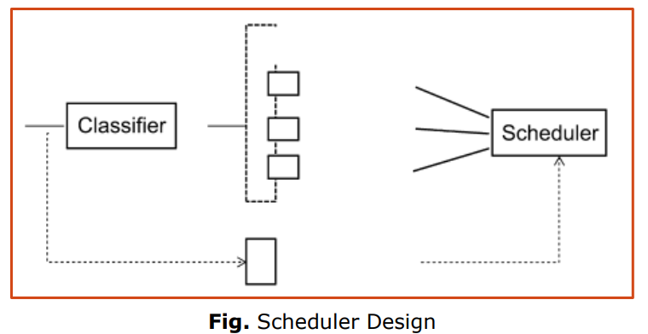
Classifier
❖ This module is responsible for sorting the incoming packets into different services classes and forwarding
them to the corresponding queues
❖ DiffServ allows the definition of multiple traffic classes
❖ A packet is classified according to the Differentiated Services Code Point (DSCP) field
❖ Applications with real-time constraints such as voice does not tolerate variation of the delay between the sent
and the received packets
❖ The guarantee of these constraints becomes more difficult in technologies which consider the mobility of the users
Note :
1. Need to differentiate the class of service for each packet.
2. First classes of services are delay intolerant : - which means that the intolerant applications such as VoIP require a
limited delay and cannot tolerate a delay higher than this limit.
3. Second class tolerates an additional delay like video traffic
4. Third class is not vital in term of delay such as data traffic

Channel quality
➢ The Media Independent Handover Function (MIHF) provides different information to the channel quality module
➢ This module uses some existing MIH services such as Link_Up, Link_Down, Link_Going_Down and Link_Get_
➢ Determine the link status and QoS parameters of different links like data rate, throughput and other information
➢ The MIES defines the functions of event classification, event filtering, and event reporting to upper layers
➢ Link_Up and Link_Down events are generated by lower layers (layer 1 or layer 2), and these events are notified to
the MIHF.
➢ Then, the MIHF reports these situations to upper layers by triggering MIH_Link_Up and MIH_Link_Down events.
Access to network-specific information like network identifier is provided by the Information Elements (IE) of the MIH
Information Services (MIIS).
Note :
1. Major concern of the quality is interference. If the estimated SINR is larger than a threshold, the channel is considered good. The channel quality module sends a message to the scheduler module which will use this information without any channel scanning procedure.
2. Each flow is associated with a channel, which is in one of the three states, namely, good, medium or bad state,at any time instant

Scheduler
➢ This module makes a scheduling decision according to :
1. The delay constraint
2. The classes of service
3. The channel status
4. The type of connection (handoff or new call)
➢ It assigns priorities according to the packets deadlines: the shorter the deadline, the higher priority is assigned to the packet
➢ Then, it serves the packets according to their priority index to the corresponding link
➢ The algorithm should be able to dynamically identify the packet with the earliest deadline and to take into consideration the instantaneous channel conditions
➢ The packet with nearest deadline and the best channel quality is given highest priority and it is selected for being served
➢ The packet will be assigned the lowest priority if its deadline is the furthest

Q7. With neat diagram, explain how network coding helps in video broadcasting from one device to multiple receivers.

Fig.1 shows video broadcasting from one device to multiple receivers. The use of network coding for direct content delivery in wireless devices

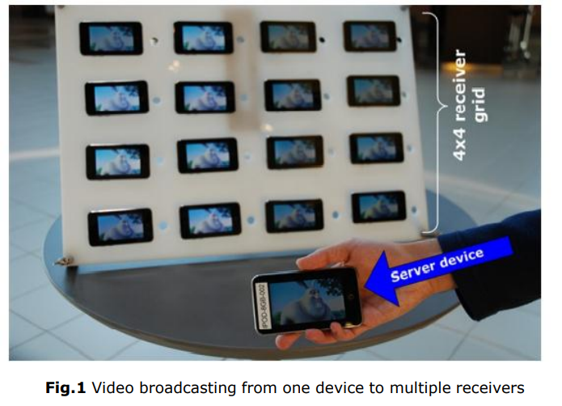

In addition, if the receiver nodes cooperate by forwarding packets to each other, the workload of the
server can be significantly reduced.In the case where the source of the content is located far
away, and the communication links are likely to be error prone, cooperative downloading is beneficial as shown in Fig. 2
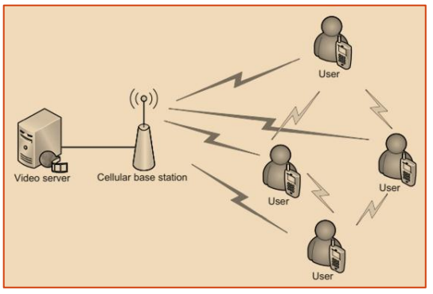
Fig.2 Content distribution in a Multi-Hop Network.

In this case the Network Coding technique can be leveraged to facilitate the distribution of data among the cooperative devices.
❖ Indeed, with the standard coding techniques, the server needs to send additional data to enable nodes to recover from errors
❖ With the network coding technique, each receiving device can forward recoded information to other nodes, alleviating the load at the server

Q8. Write a brief note on the Layered analysis in wireless networks. [6]
LAYERED ANALYSIS : According to the traditional International Organization for Standardization/Open System
Interconnection (ISO/OSI) approach.
❖ Functions of communication are shared between network layers in communication networks.
❖ Every layer can be implemented independently from the others.
❖ Well-defined interfaces between these layers and separation of duties are instrumental for modular design which lends
itself to: 1. High compatibility,
2. Interconnectivity,
3. Robustness to functionality changes.
Application Layer:
Encoding techniques and application-based optimizations provide means for high-quality multimedia transmission in
wireless networks.
❖ Improve wireless video streaming and multimedia communications
❖ To develop error resilient source coding and transmission techniques such as error protection, power saving, and proxy
management
To mitigate transmission challenges such as packet loss and bit errors and maintain high-quality media delivery in wireless
IP networks : -
✓ Error control techniques such as forward error correction (FEC)
✓ Automatic repeat request (ARQ) are instrumental
Application Layer
Varying wireless Internet conditions and diverse media characteristics of multimedia content impose challenges on how to efficiently cache both continuous and noncontinuous media.
• Robust video coding : Adjust the coding rate and other coding parameters according to the varying
network conditions (bandwidth, loss and delay).
• Source rate control : Aims to make the source rate match the channel condition to achieve better video quality at the receiver side
• Resource allocation and scheduling : Streaming video, requires per-user data rates guaranteed in
order to be of useful quality
Transport Layer
Transport layer process the data coming from the upper layer (application layer) before passing to the
network layer
Has the capability of transferring data from one node to another,
Note:
1. Transport layer splits data into smaller packets, dispatches those packets and at the receiver
reassembles the data in the correct sequence.
2. Provide the following services:
a) Flow control between the two ends, so called “end-to-end” services,
b) Dividing the streams of data into chunks/packets and reassembling at the receiving end
c) Error-checking to guarantee error-free data delivery, with losses/duplications.
3. Two classes: Reliable transport protocols TCP and unreliable transport protocols UDP.
Transport Layer
Challenges and issues in the design of a transport protocol
• Packet loss differentiation and estimation
• Available bandwidth estimation
• Mobility Management
• Inherent QoS Support
Network Layer
To use multipath transport or routing where multiple paths are used to transfer data for an endto-end session
1. Advantage of using multipath transport is the inherent path diversity (i.e., the loss processes are
expected to operate independently for different paths).
2. Capabilities and Advantages of multipath routing come at the cost of :
a. Higher coding redundancy,
b. Higher computation complexity, and
c. Additional delay during traffic partitioning & resequencing, as well as higher signaling/control traffic overhead in the network
Network Layer Challenges and issues
• Designing practical multi-stream encoder and multipath routing scheme must strive to achieve a good trade-off between coding efficiency, error resilience and throughput
PHYSICAL AND MAC LAYERS
At the physical (PHY) layer, adaptive modulation and coding known as link adaptation is a very important capability that is widely used in wireless technologies.
❖ Enables cross-layer mechanisms for configuration and monitoring of physical layer aspects
❖ Power control is realized from the group point of view by adjusting transmission power and other PHY parameters for a group of users to reduce interference.
1. Communication system utilizes higher modulation levels and higher channel coding rate when channel condition is good
2. Use lower modulation levels and lower channel coding rate when channel condition is relatively severe
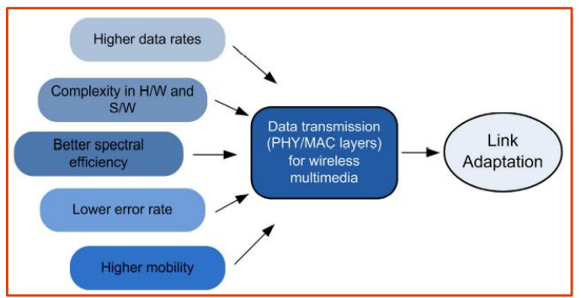
Figure Design forces for link adaptation schemes
Four mechanisms by which a system could improve link robustness at the expense of overall bandwidth efficiency :
• Adaptive modulation
• Adaptive FEC
• Automatic repeat request (ARQ)
• Optimal power and coding allocation

Q9. What are four mechanisms to improve link robustness of wireless network. Explain any one in detail
Robustness
1. Robustness to packet losses
Packet loss arises for various reasons in networks, which include buffer overflow, link outage,
and collision.
Ways to deal with such losses:-
1. To set up a system of acknowledgments by TCP mechanism
2. Use channel coding/ erasure coding. that introduces a degree of redundancy to the packets so
that the message can be recovered
3. Network coding scheme that applies additional coding at intermediate code without decoding
2. Robustness to link failures
1. Besides robustness against random packet losses, network coding is also useful for protection
from non-ergodic link failures.
2. Live path protection, where a primary and a backup flow are transmitted for each connection,
allows very fast recovery from link failures, since rerouting is not required.
3. However, this approach doubles the amount of network traffic.
By allowing sharing of network resources among different flows, network coding improves
resource usage

Q10. Explain following network performance parameters used to manage
service performance : [5]
i) Throughput
ii) Packet loss
iii) Latency
iv) Availability and
v) Reliability

Throughput: The effective data transfer rate measured in bits per second and a minimum rate of throughput is usually
supposed to be guaranteed for specific services and applications such as video
• Latency: It is defined as the delay between the time the data is sent from its origin and received at its destination
• Jitter: It represents the delay variation caused by the variations in delay experienced by the packets during end-to-end transmission such as
1. variations in queue length / in packet processing, and
2. packets traveling through different paths
Packet loss: It represents the information losses at the network level that may occur for many reasons including : -
1. Network congestion
2. Link failures
3. transmission errors
For wireless networks, transmission errors are more common compared to wired networks due to variations in channel conditions.
• Availability: It is the percentage of the time that the network is available to provide services to the end users.
• Reliability: It is defined as “the probability that a system will perform its intended functions without failure,
1. within design parameters
2. under specific operating conditions
3. for a specific period of time

Q11. Explain step by step with neat diagram, how performance evaluation of a Real System is done.
Generally, directly measuring the performance parameters of a real system is very difficult, if not
impossible.
❖ Mathematical formalism concentrating on a model, behavior and parameters that better reproduce the
functioning of the system must be proposed.
❖ Hence, model is considered as a mathematical abstraction of the real system.
❖ Defined by a set of equations or be described by means of formalism.

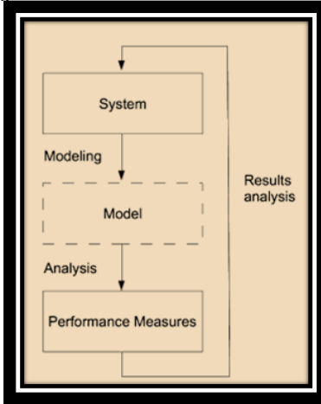
Figure. Performance Evaluation of a Real System
Figure gives an illustration of the performance evaluation of a real system.
- The looping occurs only if the results obtained are not those that one
is looking for.
Note :
▪ Performance analysis is done on the model
▪ Results obtained belong to the model and not to the system
ANALYSIS OF THE MODEL :
❖ After building the model using the required formalism, it must then be analyzed
❖ There are two main types of analysis: Qualitative analysis and Quantitative analysis
• Qualitative analysis consists of checking the structural and behavioral properties of the system
• Quantitative analysis is used to calculate the performance parameters of the system.
There are two main approaches to quantitative analysis of performance:
1. Simulation and 2. Analytical methods.
• Simulation consists of reproducing the evolution of the model, step by step, by studying a particular realization of the stochastic model.
➢ Various simulation languages can be used, such as the universal / Specific languages
➢ Advantage of simulation is to provide a general approach to studying any model, as long as the simulation tool is adapted to the model considered.
➢ Simulation is very commonly used in industry.
• Analytical methods propose to calculate the performance indices mathematically by solving the underlying equations
➢ Their interest lies mainly in their resolution as they are usually inexpensive in terms of computing time
➢ Unfortunately, the class of models that can be analyzed simply and exactly is relatively limited
Last step will be Documentation of the results

Q12. Classify Schedulers & Explain in brief. [9]
- Weighted Round Robin Scheduling
- ii) Weighted Fair Queuing.

SCHEDULING ALGORITHMS CLASSIFICATION : The scheduling can be divided into two classes
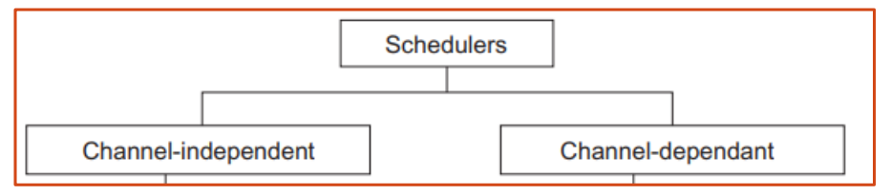
I. Channel independent strategies were first introduced in wired networks
➢ Based on the assumption of time-invariant and error-free transmission media Simplest scheduling algorithms are:
• Weighted Round Robin (WRR) scheduling
1. It is used to facilitate controlled sharing of the network bandwidth
2. WRR assigns a weight to each queue; that value is then used to determine the amount of bandwidth allocated to the queue
II. Channel-dependent scheduling schemes may be used to take advantage of favorable channel conditions to increase the throughput and system spectral efficiency.
Scheduling algorithms are:
• Weighted Fair Queuing (WFQ Scheme):
1. Here, the packets are grouped into various queues.
2. A weight is assigned to each queue which determines the fraction of the total bandwidth available to the queue.
3. The weight may depend on both channel quality and the number of packets in the queue of individual users.
4. It provides balanced resource utilization between fairness and efficiency.

Q13. With neat diagram, use of network coding for Content distribution in a multi - Hop network

Ans: Refer Q7 for this answer.(Fig. 2)

Q14. With neat diagram, use of network coding for Content distribution in a multi - Hop network
Refer Q8 Answer PHYSICAL AND MAC LAYERS point.

